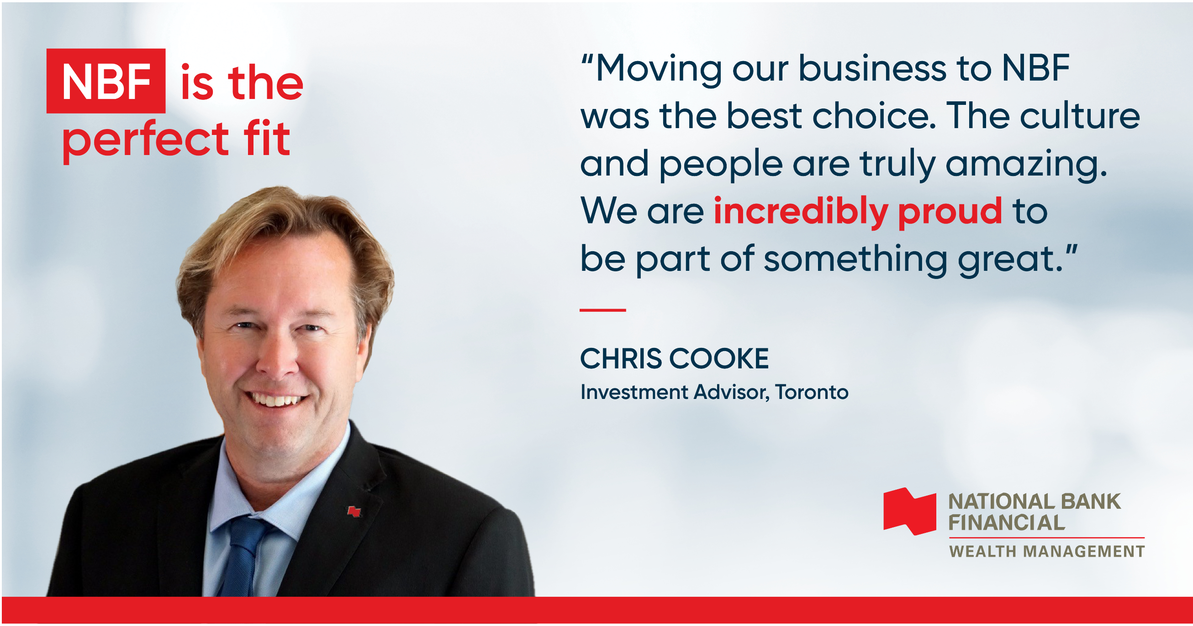

National Bank Financial – Wealth Management was founded in 1902 and has grown to become one of the largest brokerage and wealth management firms in Canada. It is a key business line outside of Quebec for National Bank of Canada, a leading Bank and integrated financial group.

**We do things differently**

With 800 investment advisors managing over $120 billion in assets from coast-to-coast, we offer the best of both worlds with the entrepreneurial culture of a boutique firm and the strength of a chartered bank.

We consider our investment advisors like partners and support them with comprehensive resources and industry-leading investment solutions while giving them the freedom to excel as entrepreneurs. Our executive and regional management teams are open-minded, creative and accessible.



Simon Lemay, Senior Vice-President and National Sales Manager

*“Choosing the right brokerage firm to better serve your clients and finding a partner that will help you grow isn’t easy. Many investment advisors choose NBFWM for our entrepreneurial culture. We offer a unique combination of independence and passion for the industry.”*

To find out why so many investment advisors moved their practice to NBFWM, [click here](https://www.nbfwm.ca/grow-your-career.html).

National Bank Financial - Wealth Management (NBFWM) is a division of National Bank Financial Inc. (NBF), as well as a trademark owned by National Bank of Canada (NBC) that is used under license by NBF. NBF is a member of the Investment Industry Regulatory Organization of Canada (IIROC) and the Canadian Investor Protection Fund (CIPF), and is a wholly-owned subsidiary of NBC, a public company listed on the Toronto Stock Exchange (TSX: NA)